**Project Design Phase-I**

**Solution Architecture**

|  |  |
| --- | --- |
| Date | 19 September 2022 |
| Team ID | PNT2022TMID17990 |
| Project Name | Personal Assistance for Seniors Who Are Self-Reliant |
| Maximum Marks | 4 Marks |

**Solution Architecture:**

Solution architecture is a complex process – with many sub-processes – that bridges the gap between business problems and technology solutions. Its goals are to:

* An app is built for the user (caretaker) which enables him to set the desired time and medicine which those details will be stored in the IBM Cloudant DB.
* If the medicine time arrives the web application will send the medicine name to the IoT Device through the IBM IoT platform by voice alarm.

**Example - Solution Architecture Diagram:**

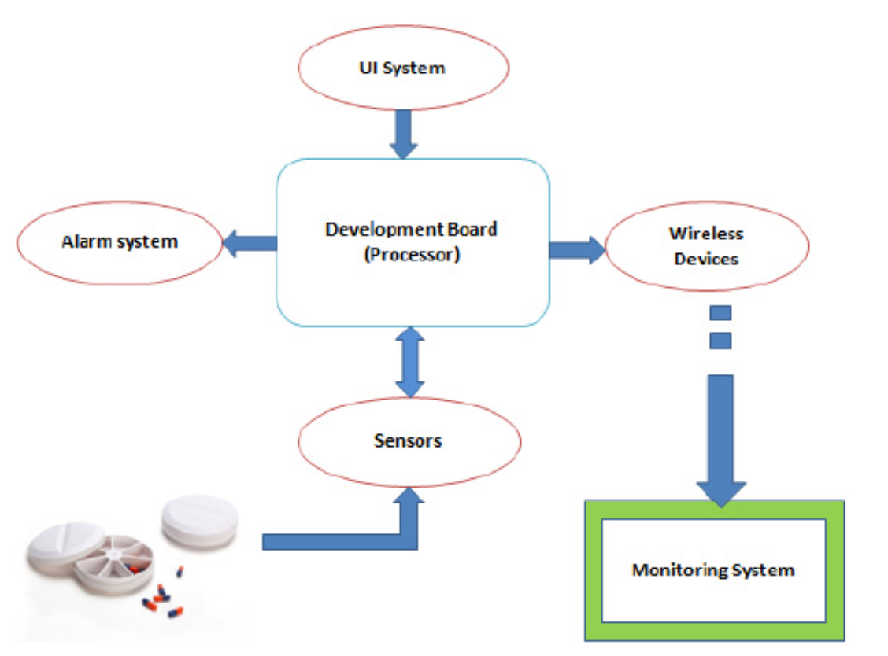

Figure 1: Architecture of Personal monitoring system for medicine

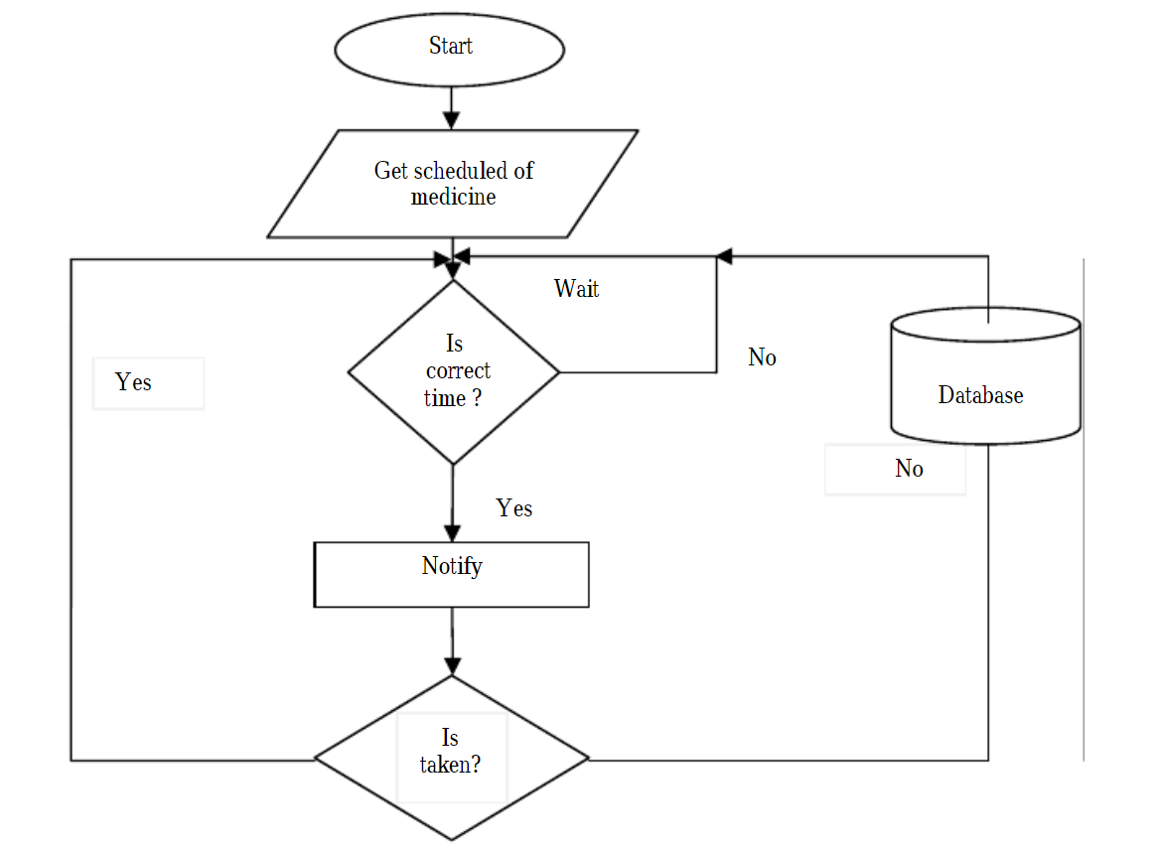

Figure 2 : Flow chart of how the application works on

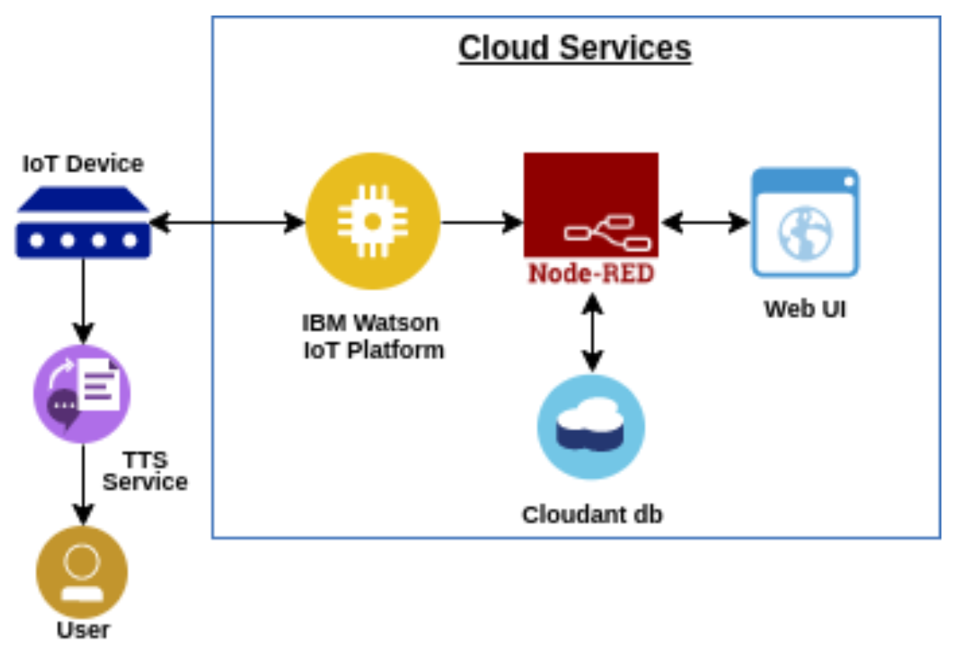

Figure 3: Technical Architecture of the voice patient diary application